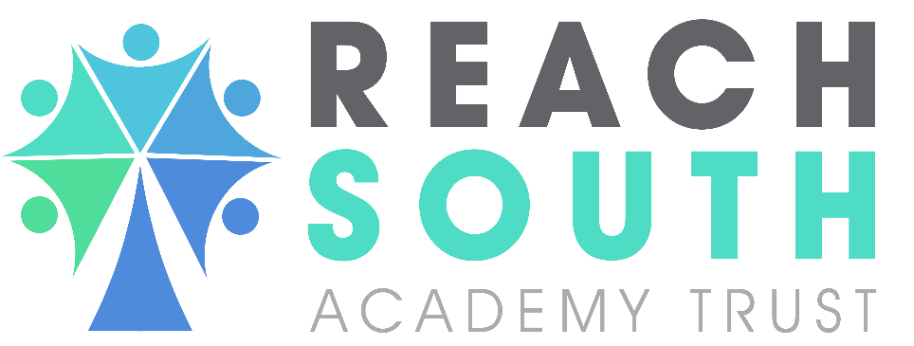
MARKING AND FEEDBACK PROTOCOL: PRIMARY ACADEMIES

Approval Date
Document Owner | Jackie Green
Adopted by Trust Board
Review Date | September 2026

CONTENTS

Section | Description | Page No.
1 | Aims | 3
2 | Rationale | 3
3 | Research | 3
4 | Specific Considerations for Specialist Settings | 4
5 | Equal Opportunities | 4
6 | Principles of Feedback | 4
7 | Sustainability and Workload | 5
8 | Implementation | 5
9 | Verbal Feedback | 6
11 | Written Feedback | 7
12 | Marking Codes | 7
13 | EYFS | 7
14 | Misconceptions Versus Mistakes | 7
15 | Monitoring Arrangements | 7
16 | Supporting Policies | 7
17 | Protocol History | 8

Aims
  - This protocol aims to:
- Raise standards of every pupil’s achievements
- Recognise pupil effort and achievement
- Provide encouragement and confidence to strive higher
- Specify the ways in which a piece of work could be improved
- Stimulate a dialogue between staff and pupils rather than be a formative process
- Provide information for assessment so the next stage of learning can be suitably planned for and individual next steps and targets set
- Teach pupils to respond to their learning so that they can self-assess and evaluate their own learning
- Enable a whole school approach to feedback that is clearly received, interpreted and used by all children and staff to move learning on.
- Inform the Teacher of individual children’s progress, enable them to plan future work effectively and make informed judgements regarding a child’s attainment.
- Ensure consistency within and across year groups ensuring all have equally high expectations of their pupils
- Have a consistent and easy to use marking procedure (with clear symbols and expectations)
- Ensure colleagues understand it is the quality not quantity of feedback that matters so that they are clear where to inject challenge, what type of assessment will be best placed to reveal the gaps in learning and how to make pupils think deeply in response to high quality feedback.
- Ensure that all feedback and marking supports ‘closing the gap’ with a particular emphasis on ‘under resourced children’.

Rationale
  - This is a Trust wide protocol to ensure alignment of the key principles of marking and feedback. Its key purpose is to raise and improve standards across the Trust and to ensure a baseline of quality, through establishing and sharing good practice.
  - Feedback comes in a variety of forms and should be a regular and robust part of every lesson. Feedback, as an integral part of the learning process, must be precisely positioned and delivered regularly in each aspect of the lesson. All feedback should have a positive tone. It should be specific, clear and appropriate in its purpose and productive in its outcomes. The best feedback, whether it is written or verbal, will give pupils a clear sense of how they can improve, with pupils responding and making progress as a result.

Research
  - Our protocol is underpinned by the evidence of best practice from the Education Endowment Foundation and other expert organisations. Their 2021 good practice guidance on Teacher Feedback to Improve Learning (https://educationendowmentfoundation.org.uk/education-evidence/guidance-reports/feedback) states that "effective feedback should focus on moving learning forward, targeting the tasks, subject and self-regulation strategies.".
  - The Eliminating unnecessary workload around marking report (https://www.gov.uk/government/publications/reducing-teacher-workload-marking-policy-review-group-report) highlighted “that marking had become a burden that simply must be addressed” (DfE, 2016). In line with this, written evidence of feedback given should always be proportionate and for the benefit of the learner - and not simply to provide additional evidence for external verification.
  - The EEF 2016 Marking review (https://educationendowmentfoundation.org.uk/education-evidence/evidence-reviews/written-marking) highlighted that the quality of existing evidence in relation to written marking and feedback, identifying some features of marking and feedback that are unhelpful to the learner.

Specific Considerations for Specialist Settings
  - Autistic learners may have poor self-image, low self-esteem and may not always have an accurate view of their own or others' abilities. They may find it difficult to assess the standards they achieve, and some may be driven by an internal desire for perfection. Some autistic learners may find verbal feedback particularly difficult because It requires engaging in a social Interaction and this may mean the learner finds it difficult to process the feedback as described in work by Larson et al (2015) (https://pubmed.ncbi.nlm.nih.gov/21122921/) or that they are focused on how to engage in the conversation and what they should say next rather than being able to focus on the points being made.
  - All contributions made by learners are to be valued, acknowledged and commented upon in some form by staff. These comments will be framed in positive language directed to the learner and may be delivered verbally or in written form. No assumptions should be made on the above considerations. Engagement with the learner and with parents / carers is crucial to understand what factors are important to each individual and what will work best in order to support them in their learning.

Equal Opportunities
  - The protocol of Reach South Academy Trust is to offer equality of opportunity to all children irrespective of race, gender, or background, and to cater as far as possible to the individual needs of all children in respect of their capabilities, interests and expectations.
  - Reach South takes into consideration the following articles (from The United Nations Convention on the Rights of the Child) in respect of children’s rights through our marking and teaching of presentation:

  - Article 29 (goals of education) Education must develop every child’s personality, talents and abilities to the full.

Principles of Feedback
  - Feedback to pupils should be “just in time, just for them, just for where they are in their learning process and just what they need to move forward” (Hattie, 2012). Therefore, we understand for effective feedback to take place the following must occur:
  - Children must understanding what they are learning – the learning objective (we are…) is shared at the point where is best for the children.
  - Success criteria (to do this…) will be developed with the children. This can be done in a number of ways such as:
    - Creating them after appropriate modelling from the adult.
    - Children correcting or reordering them.
    - Through seeing an end product and identifying how success was achieved.
  - Children are given opportunities to compare their work with the learning objective:
    - Children can articulate to peers and adults their understanding of the task and how it links with the learning objective.
    - Mini plenaries and showing examples enables children to analyse them for success or improvement.
  - Children are given opportunities to improve:
    - A range of feedback (see below) prompts children to edit and improve in purple pen.
    - Reviewing and improvement is ongoing through self and peer assessment also in purple pen.

Sustainability and Workload
  - Marking must be regular for all children in order to ensure sustained progress; therefore, all Teachers must give time to this vital part of assessment for learning. Finding time for marking can be challenging, but Teachers must remember that long dialogue is unnecessary.
  - The complexity of the marking comments will depend on the following considerations:
- Age of the children
- The learning intention/objective
- The phase of teaching
- The subject being taught

7.3 Written feedback can be reduced to a short challenge or question: sustainability and workload are key considerations. Challenges set should always relate to deeper thinking around the concept taught.
7.4 Effectively managing the marking workload:
- Wherever possible, written feedback (marking) can take place alongside the child, but we understand that this becomes more difficult as the age and output of the children increases
- TAs can support with marking when the marking is purely summative (e.g. maths test questions) and use the highlighters for live marking in sessions
- The expectation is that as children progress through the school, they will respond in more detail and the vital dialogue between learner and Teacher will develop further.

Implementation
  - It is vital that adults evaluate the work that children undertake in lessons, and use information obtained from this to allow them to adjust their teaching. All feedback should be against learning objectives and/or success criteria and will address gaps in prior learning. Feedback occurs at one of these three stages in the learning process:
- Immediate feedback – at the point of teaching
- Summary feedback – at the end of a lesson/task, beginning of the next lesson
- Review feedback – away from the point of teaching
  - Therefore:
    - Feedback is given in different forms; both verbal feedback and marking are used (see codes below).
    - Reflective marking is completed using highlighters by the Teacher or support staff.
    - Written feedback will model the school’s presentation and handwriting expectations.
    - Marking codes will be used in all marking, across all subject areas.
    - Marking codes are accessible and understood by all.
    - Response to marking time is given whenever feedback is given.
    - Children respond in purple pen when feedback is given and is used for reflective responses made after the feedback.
    - All adults are responsible for providing feedback.
- Verbal Feedback
  - This is the most frequent form of feedback used and will be used in all lessons across the curriculum. Pupil conferencing is an integral part of all feedback and marking, it can be adult or child led, skilled questioning and prompting is used to help children improve their existing learning as well as prepare for their future learning opportunities. When providing verbal feedback it is important that:
- Areas of achievement are acknowledged and communicated to the child as well as next steps.
- Children are able to act on feedback immediately.
- Children are informed of and able to correct any errors.
- Adults can provide additional opportunities to consolidate learning or extend and deepen knowledge and understanding.
- Children are to be encouraged to seek feedback from the adults they are working with or their peers.
- Clear models of excellence are shown to learners; left on display and referenced when providing feedback.
  - Verbal feedback can be given:
- One to one
- Small groups
- Whole class
- Mini class plenaries
- Interventions
- Visualiser stops are used when needed. These could focus on a child’s work, a Teacher generated example, feedback against learning objectives and/or success criteria.
  - Schools may need to include specifics around manageability.

Children Responding to their Learning
  - There is an expectation that children are given an opportunity to respond to the feedback and marking given.
  - Marking expectations are consistent for each key stage. However, the level of marking is adjusted to match the children’s ability and when necessary SEND or EAL needs.
  - It is recognised that some children will require additional training and guidance in ‘how to respond’ to marking.
  - Children respond to marking in a series of ways dependent on their age and attainment level. Children from year 1 to year 6 use a purple pen to make corrections and edit their work based on the written or verbal feedback of an adult or peer.
  - Children in EYFS respond to feedback verbally
- Written Feedback
  - Written feedback is to be used when the Teacher determines that it is the most effective and relevant type of feedback for the subject/lesson/pupil or context.
  - Written feedback to link back to the learning objective and steps for improvement.
  - Incorrect spellings, punctuation and grammar should be identified with orange highlighter.
  - Errors are highlighted in pink
  - Where a child meets the learning objective or success criteria an adult highlights this in green.
- Marking Codes
  - All staff will model high expectations, across all subjects, within their feedback following the school’s presentation and handwriting guidelines.
  - All staff are to use the agreed marking codes as per this protocol:
  - 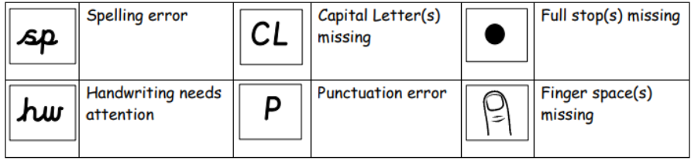
- EYFS
  - In EYFS feedback is principally given verbally.
  - Pen will be used to mark and annotate children’s work to identify errors.
  - Whole school marking codes to be used but adapted to suit the needs of the child.
- Misconceptions Versus Mistakes
  - Children may make mistakes e.g. forget a capital letter but evidence shows that they know how. Children are to be expected to find the ‘mistake’ and correct them themselves in purple pen. Guidance is given verbally or through the marking codes.
  - Misconceptions are an understanding issue e.g. uses ‘they was’ repeatedly showing they do not have the concept.
  - Misconceptions are noted by the adults, fed back into planning and addressed appropriately through direct teaching with the individual, group or the class or through written feedback.
- Monitoring Arrangements
  - This protocol will be reviewed and approved by the Assessment Improvement Team every three years.
  - SLT of each school to monitor and evaluate the effective implementation of this protocol.
  - At every review, the protocol will be shared with the local governing body.
- Supporting Policies
  - Policies that support:
- Teaching and learning
- Curriculum
- SEND
- Subject specific policies
- Inclusion
- EYFS

- Protocol History
Date | Summary of change | Contact
September 2025 | New Protocol | Jackie Green

